Required Coding Activity 12.3: Modify a Key-Value Database in a Container
Prep:
Open PowerShell and run: This pull the Redis Image.
Purpose: Downloads the official Redis image from Docker Hub.
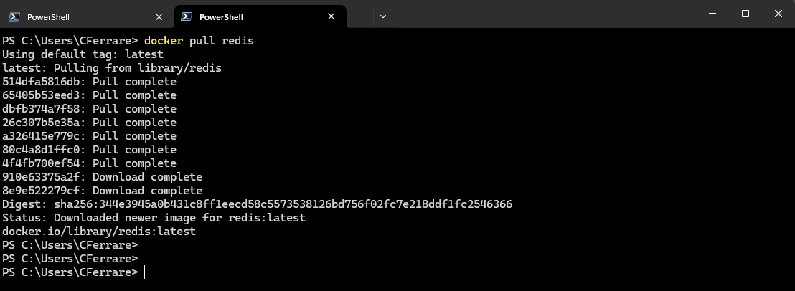

Create the Redis Container:
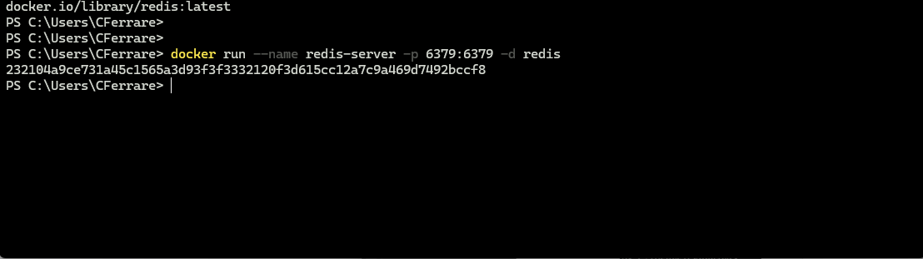
Verify Redis Is Running:
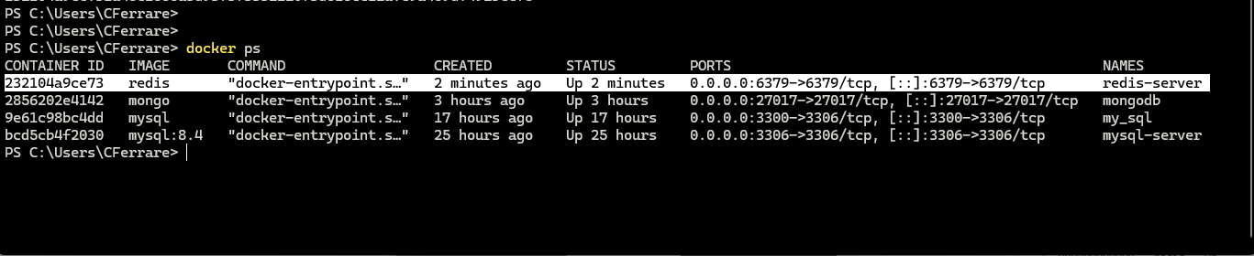

Steps:
- A screenshot showing that you opened the Activity 12.3 folder in VS Code.

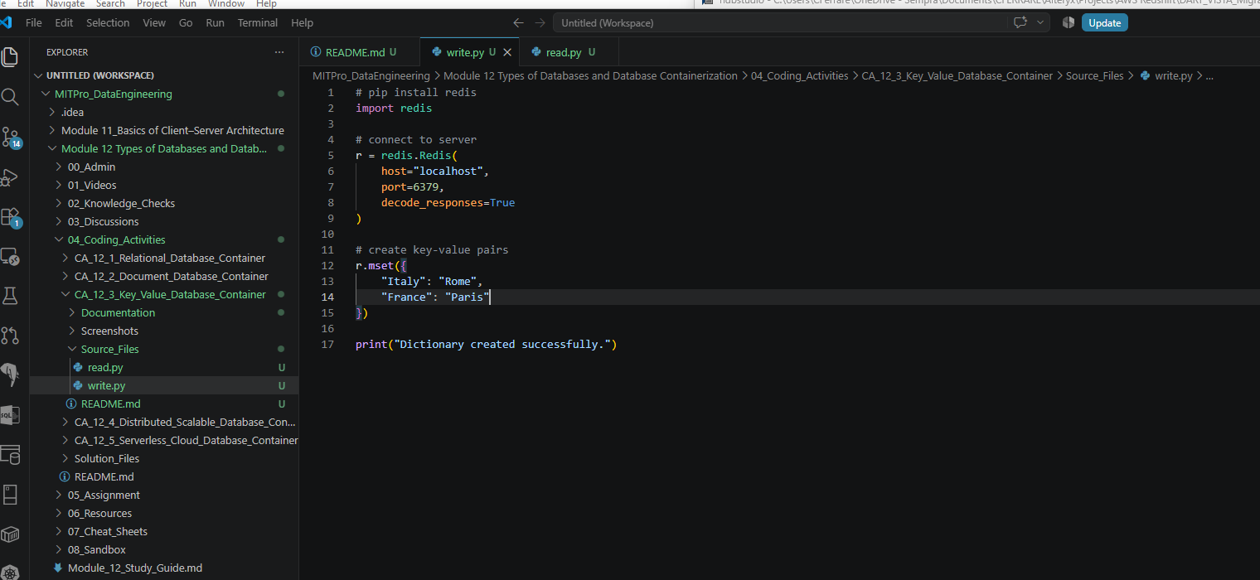

- Two screenshots showing that you successfully initialized the container in your Terminal window and that it is running in Docker.

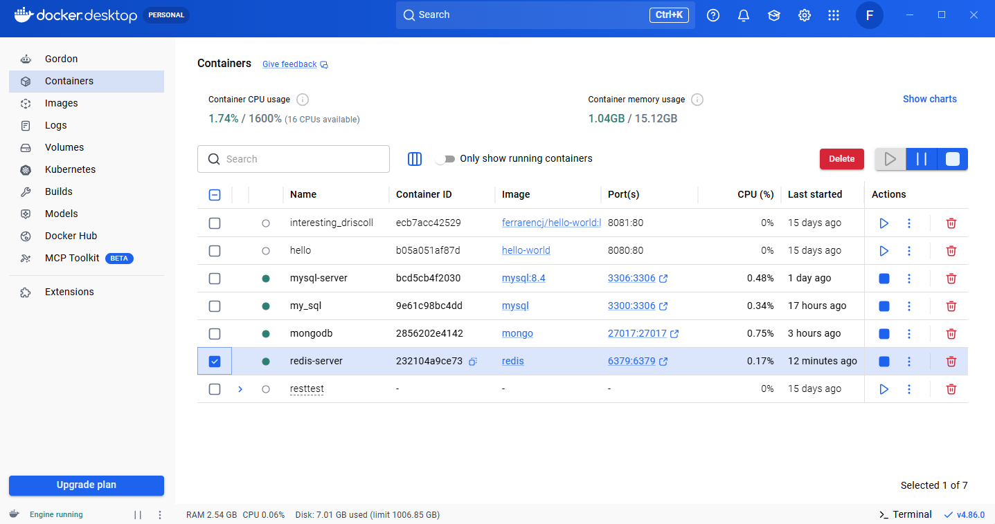

- A screenshot to show that you successfully defined the dictionary in the write.py file.

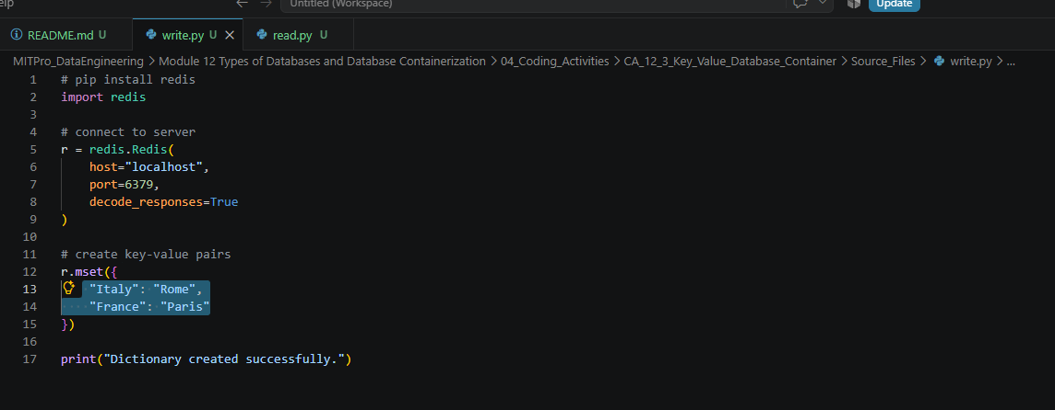

- A screenshot of your Terminal window to show that the write.py file runs without errors.

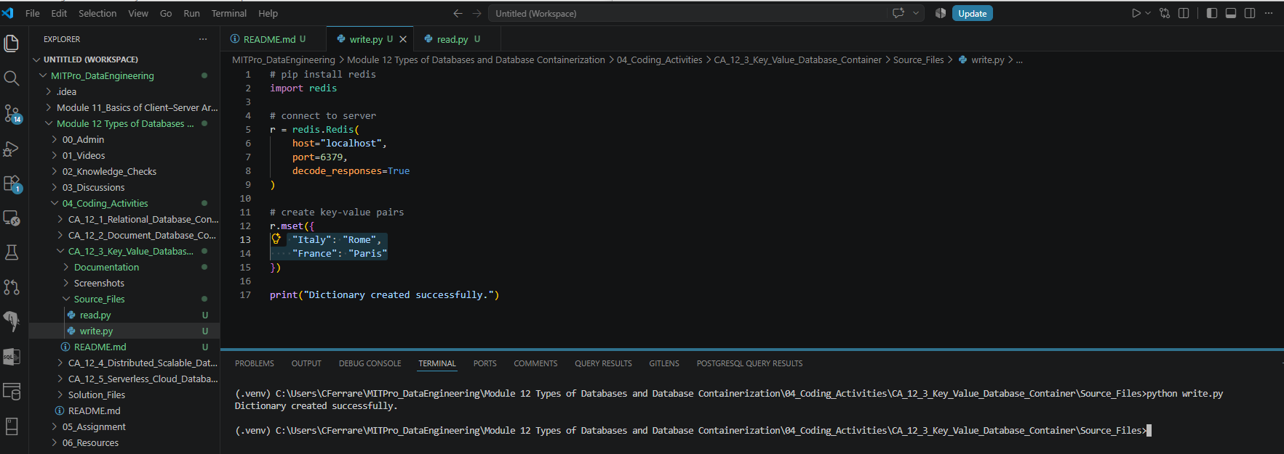

On VSCode:
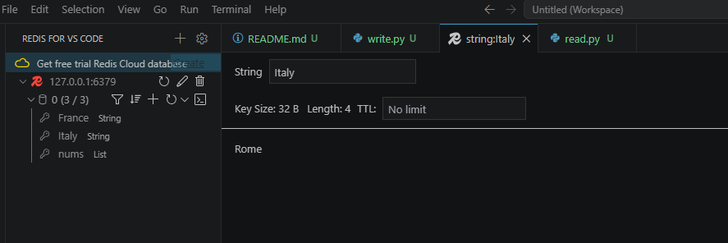

- A screenshot to show that the read.py file has been modified.

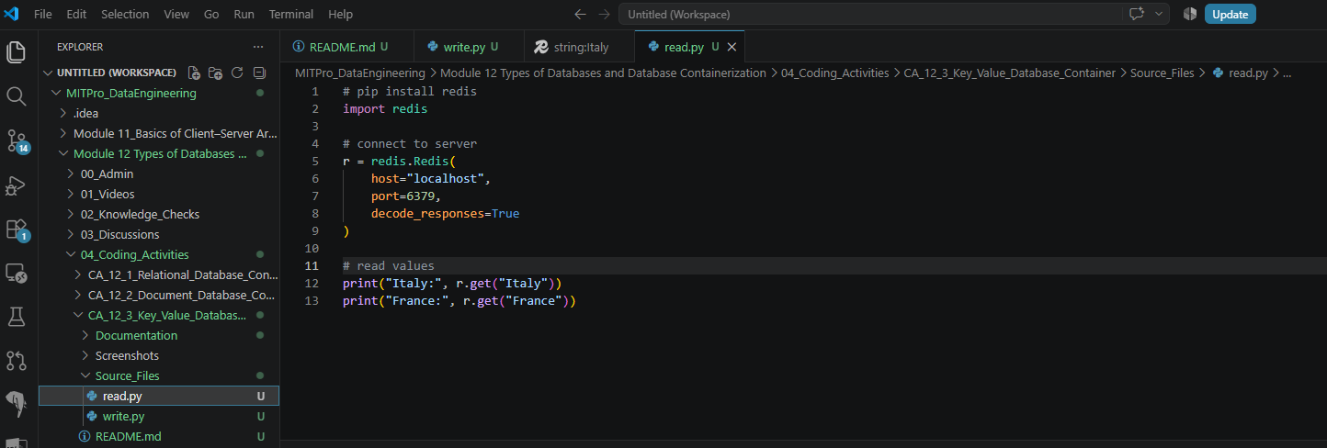

- A screenshot of your Terminal window to show that the read.py file prints the dictionary values correctly.
